|  |  |
| --- | --- |
| **Name** | **Email** |
| Norah Alsadhan | Norah_alsadhan@hotmail.com |

|  |  |  |
| --- | --- | --- |
|  | Malware Name | Hash |
| **1** | DeepScan:Generic.Tinukebot.1.C8A2DF7F | a34b5789d2631aecfe7f42477f275f04c54342f7f007612bbed58a1d39c992c5 |

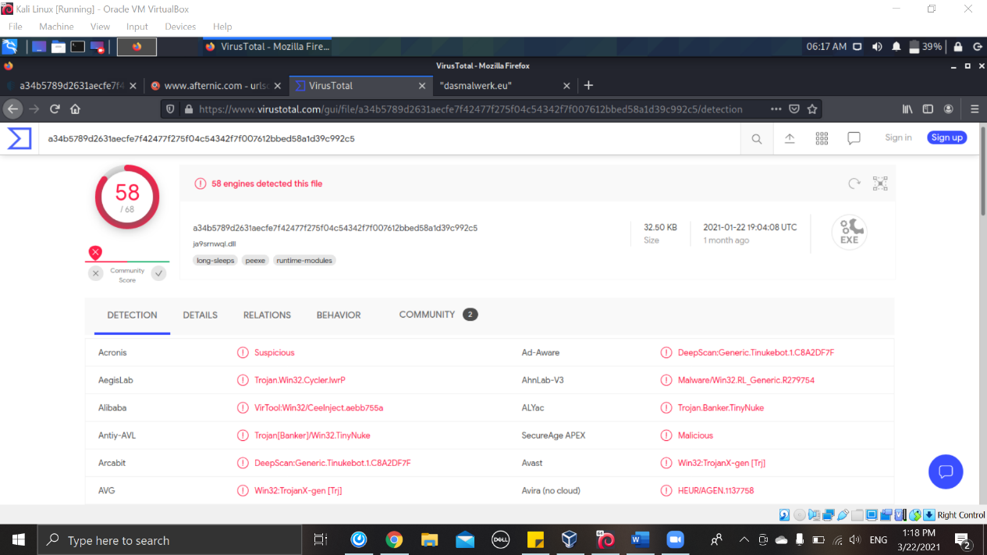

Figure 1

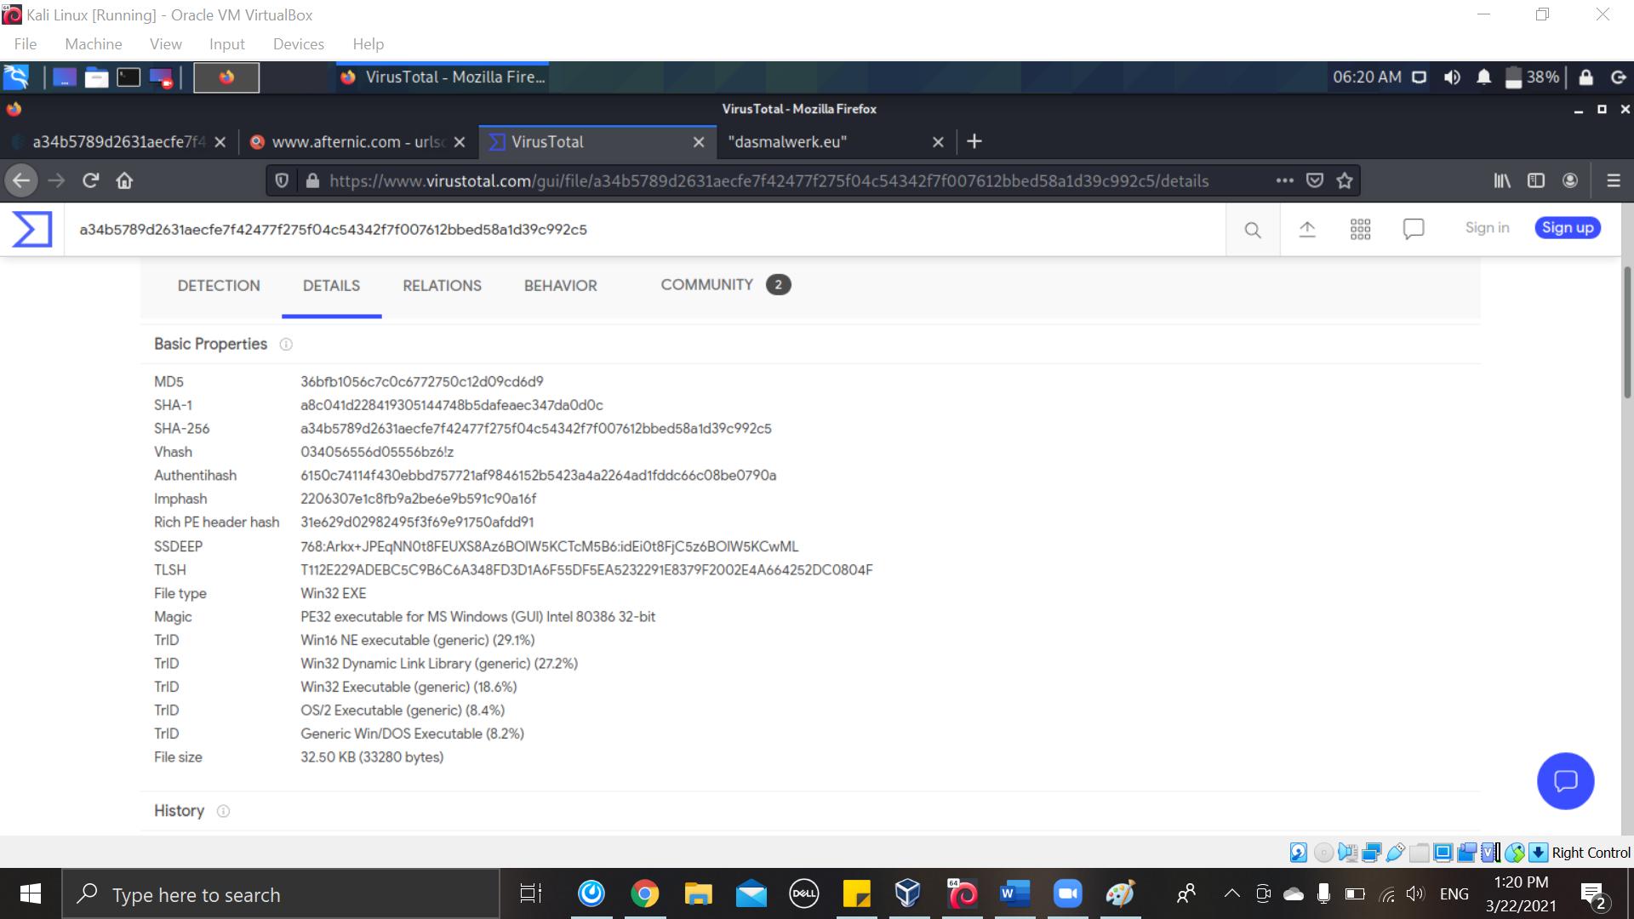

Figure 2

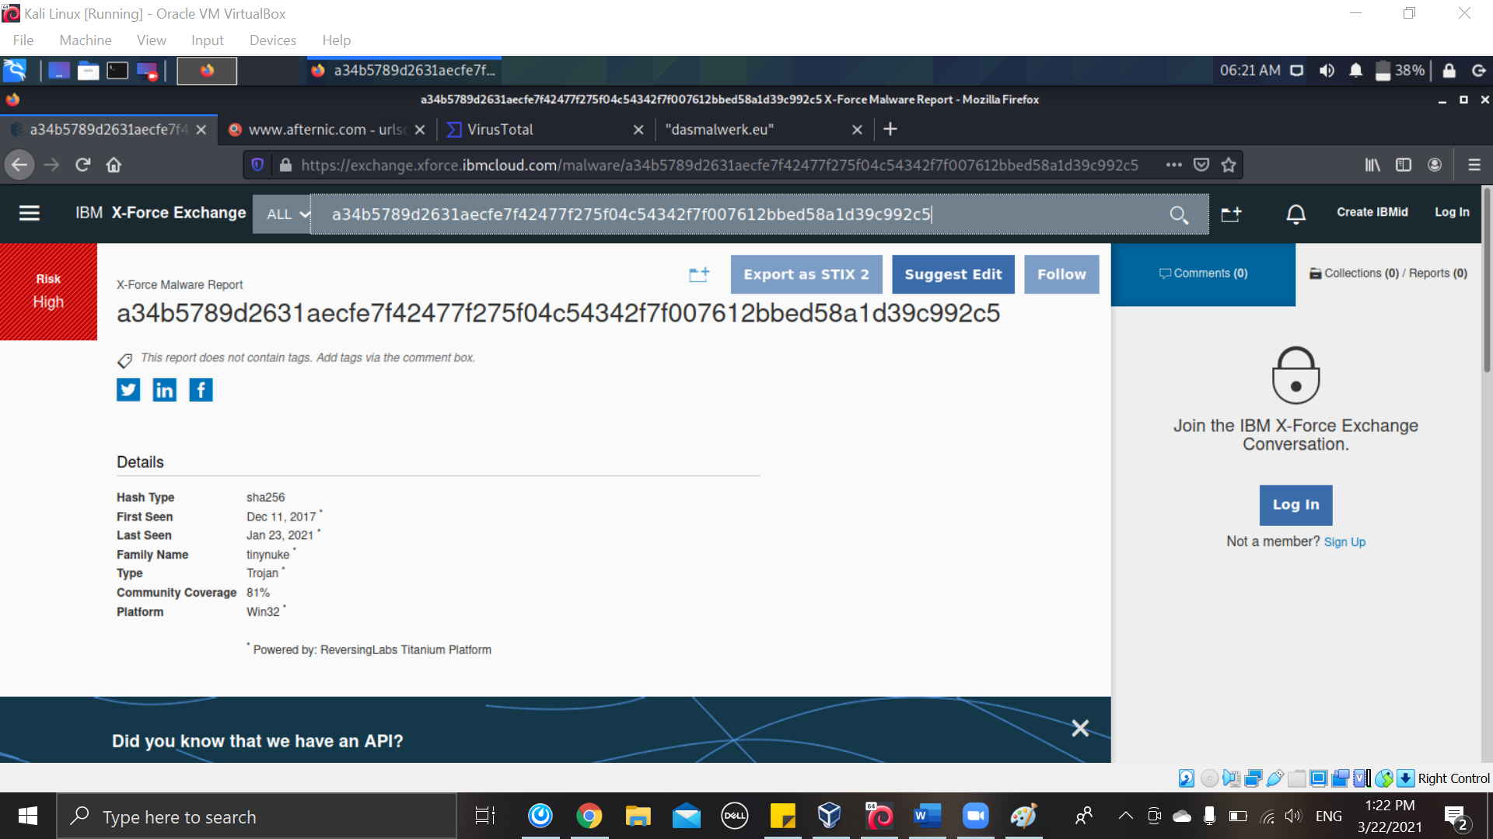

Figure 3

|  |  |  |
| --- | --- | --- |
|  | Malware Name | Hash |
| **2** | nDropper.Dapato | aaba7017a475552902d747b430c8c3effb23dd9713976fe279485bcfc4d357ec |

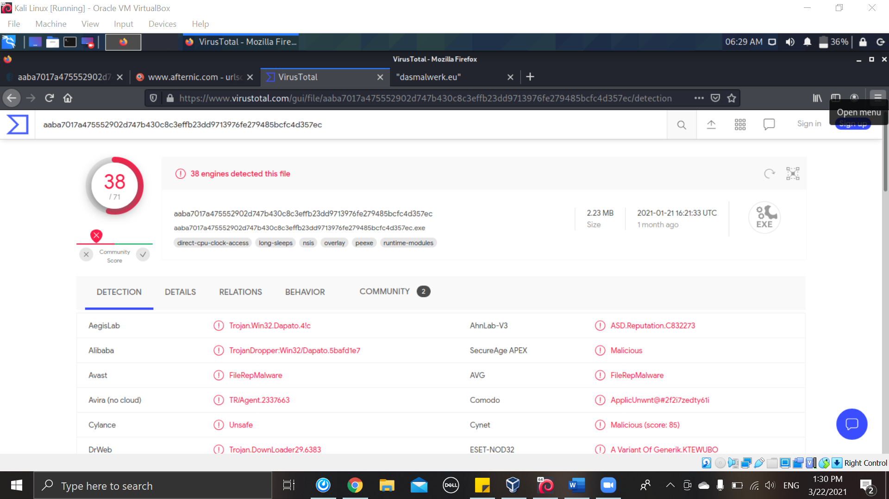

Figure 4

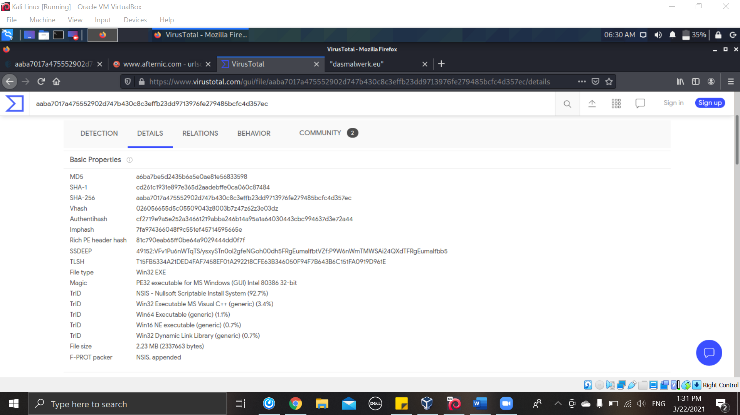

Figure 5

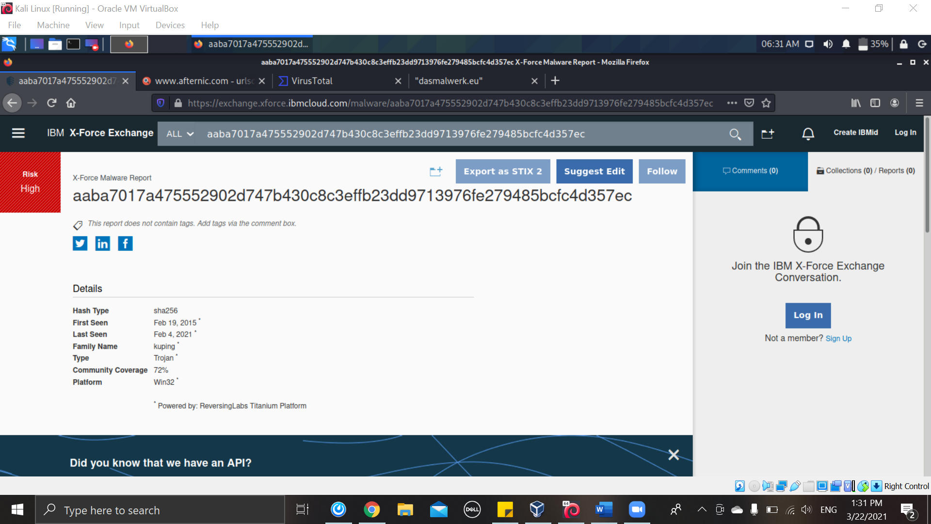

Figure 6

|  |  |  |
| --- | --- | --- |
|  | Malware Name | Hash |
| **3** | 'Password-Stealer ( 004afe551 ) | c7c5656e3d27650f567e10fa2f02ddd27b0cc910518d1676495d1f69a3ff7f13 |

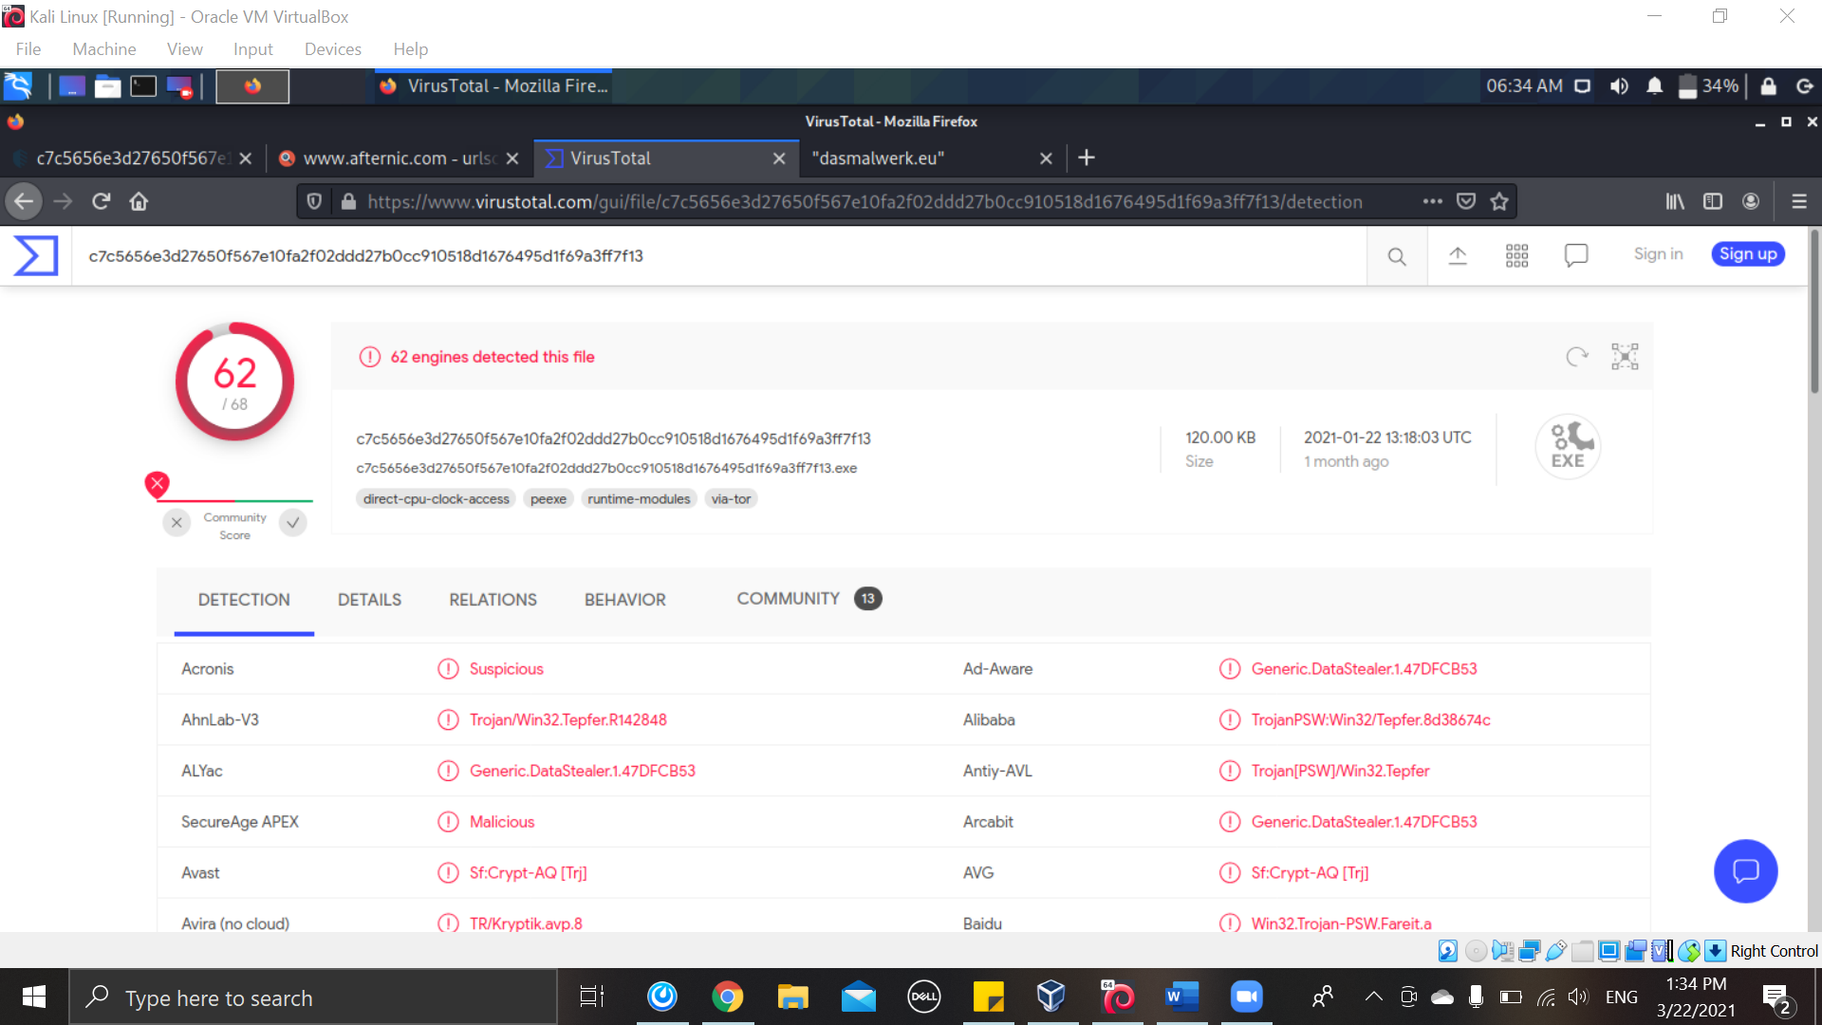

Figure 7

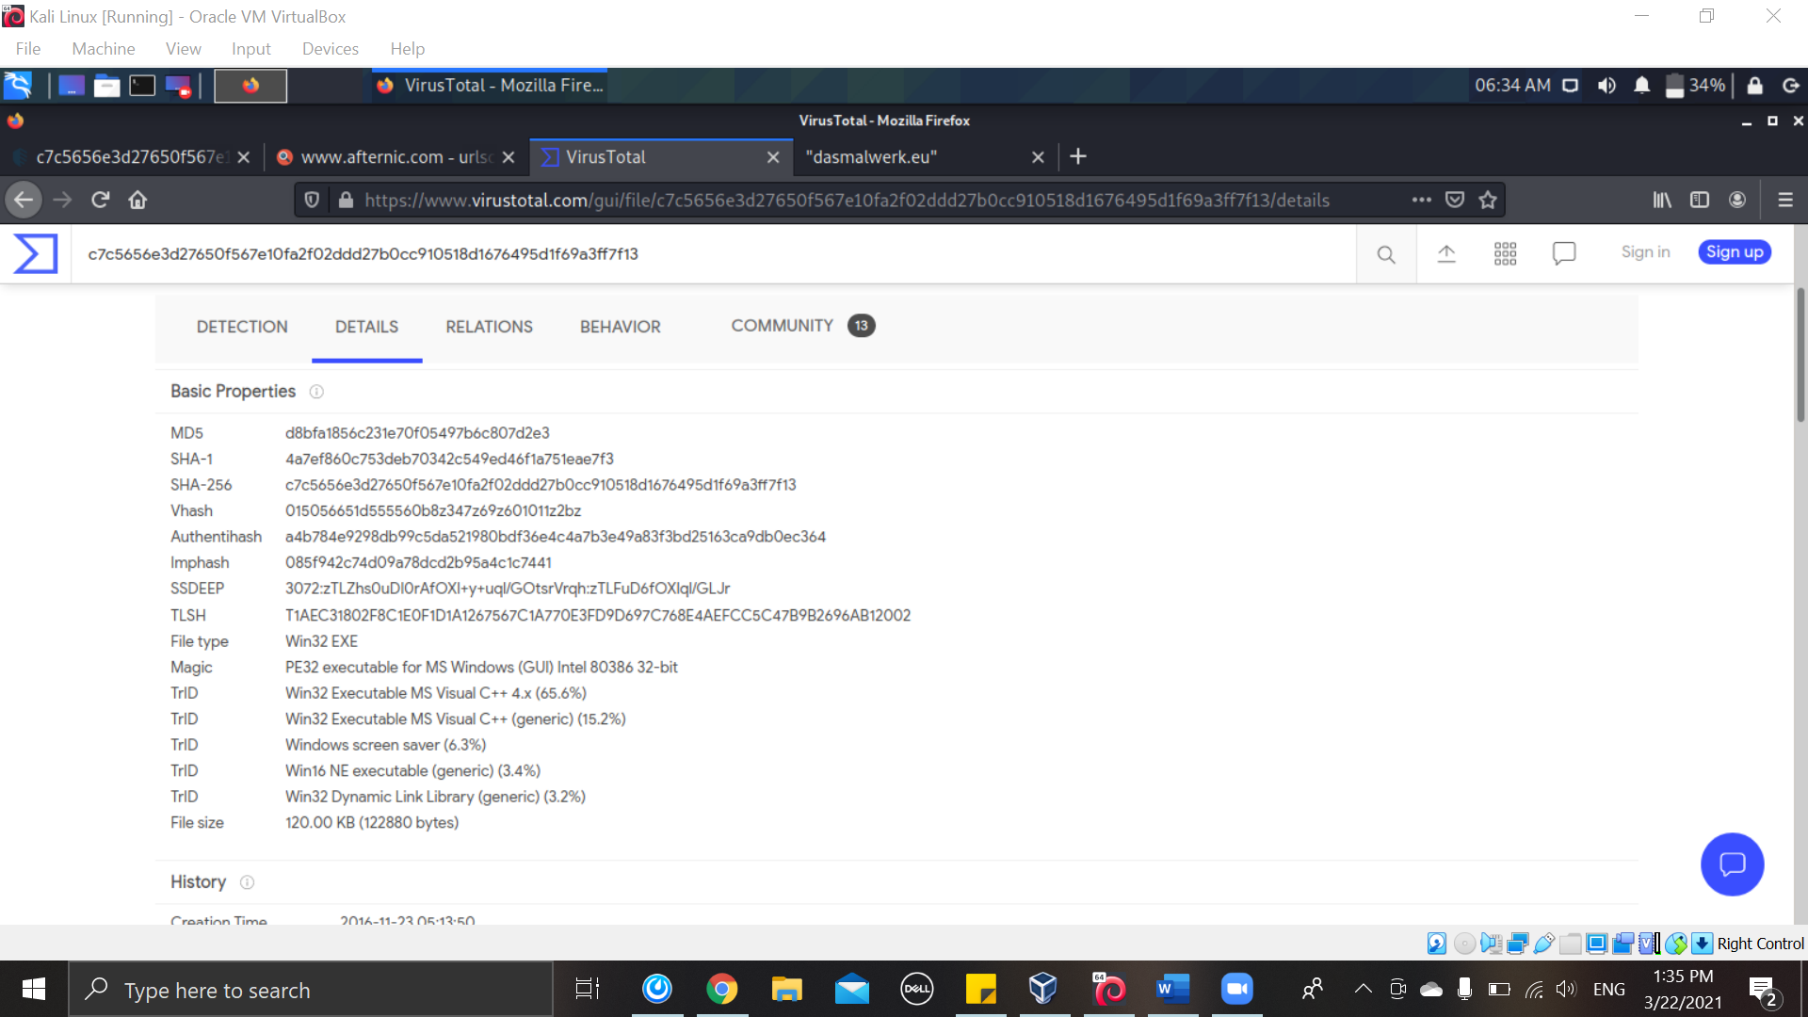

Figure 8

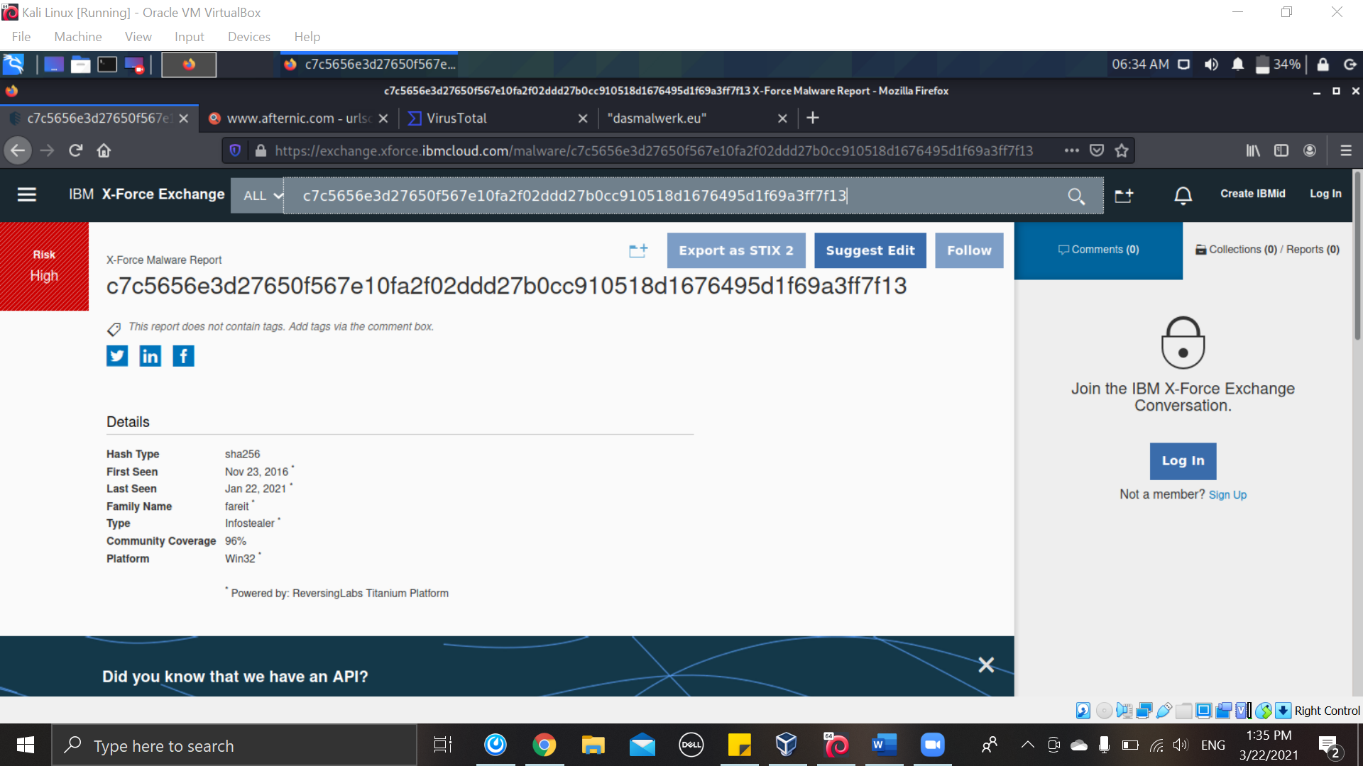

Figure 9

|  |  |  |
| --- | --- | --- |
|  | Malware Name | Hash |
| **4** | Backdoor.MSIL.Agent.GD | ea721b83c12fd31e7df6bbf8d1516c663046cc809e6fa2672b27b3b6c113bf23 |

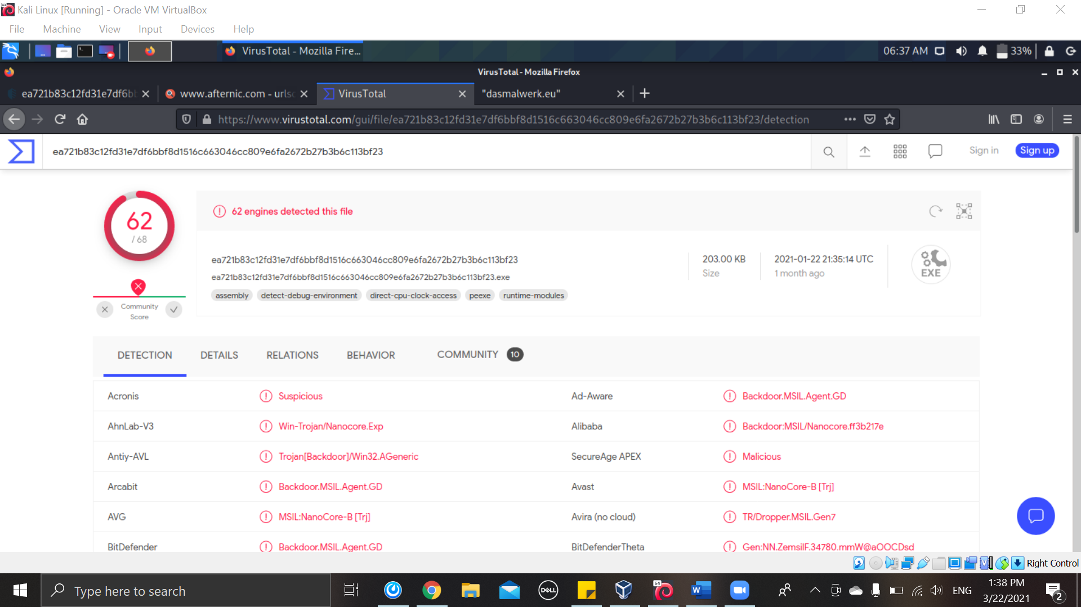

Figure 10

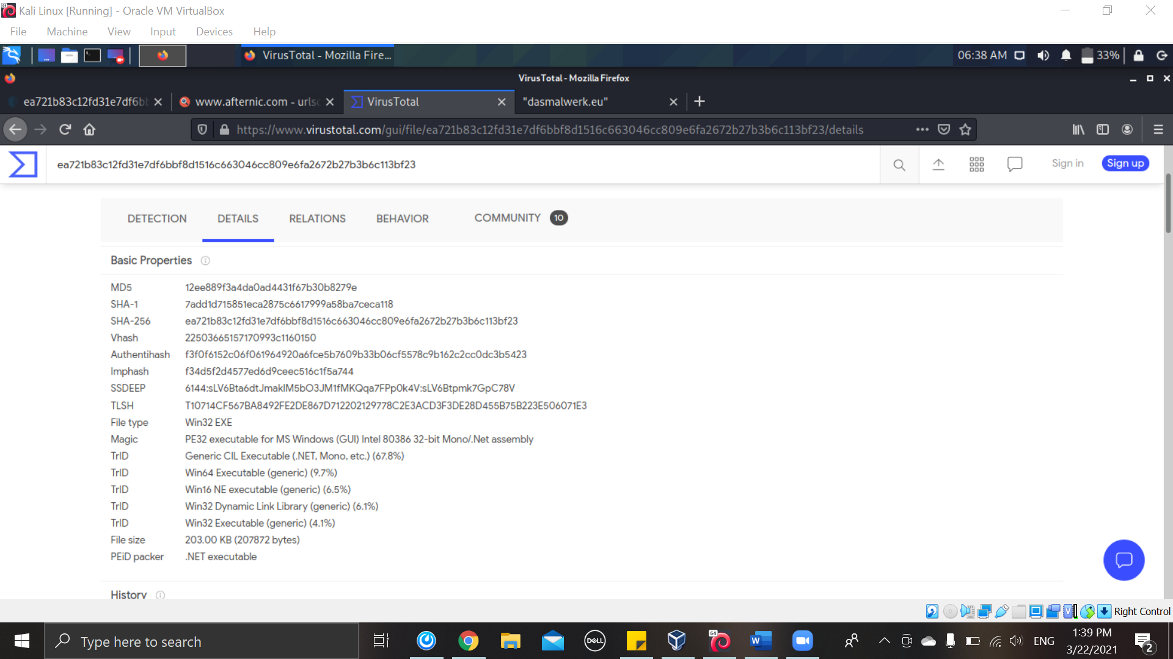

Figure 11

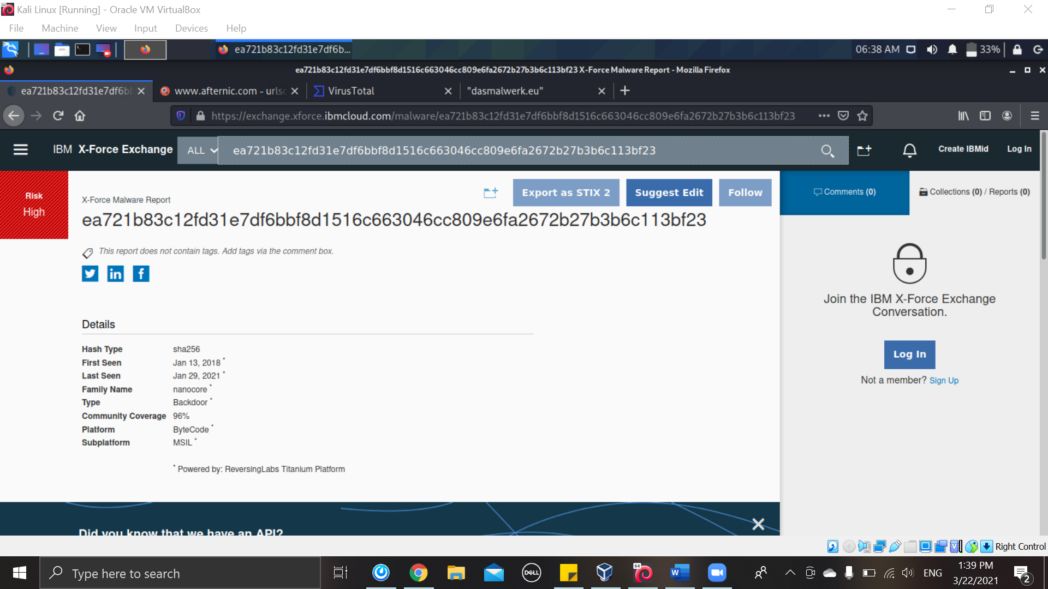

Figure 12

|  |  |  |
| --- | --- | --- |
|  | Malware Name | Hash |
| **5** | nsafe | 4733ee6718e8888331b6cfc61eeba4485dda993c4c59688f1c4a82556b67fa7a |

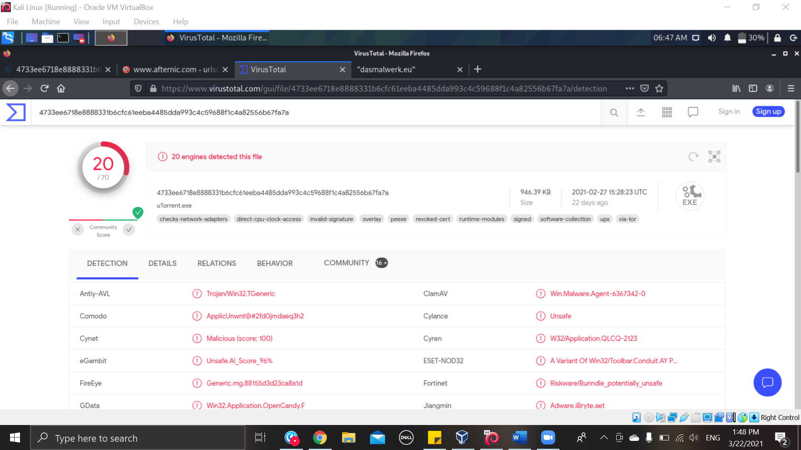

Figure 13

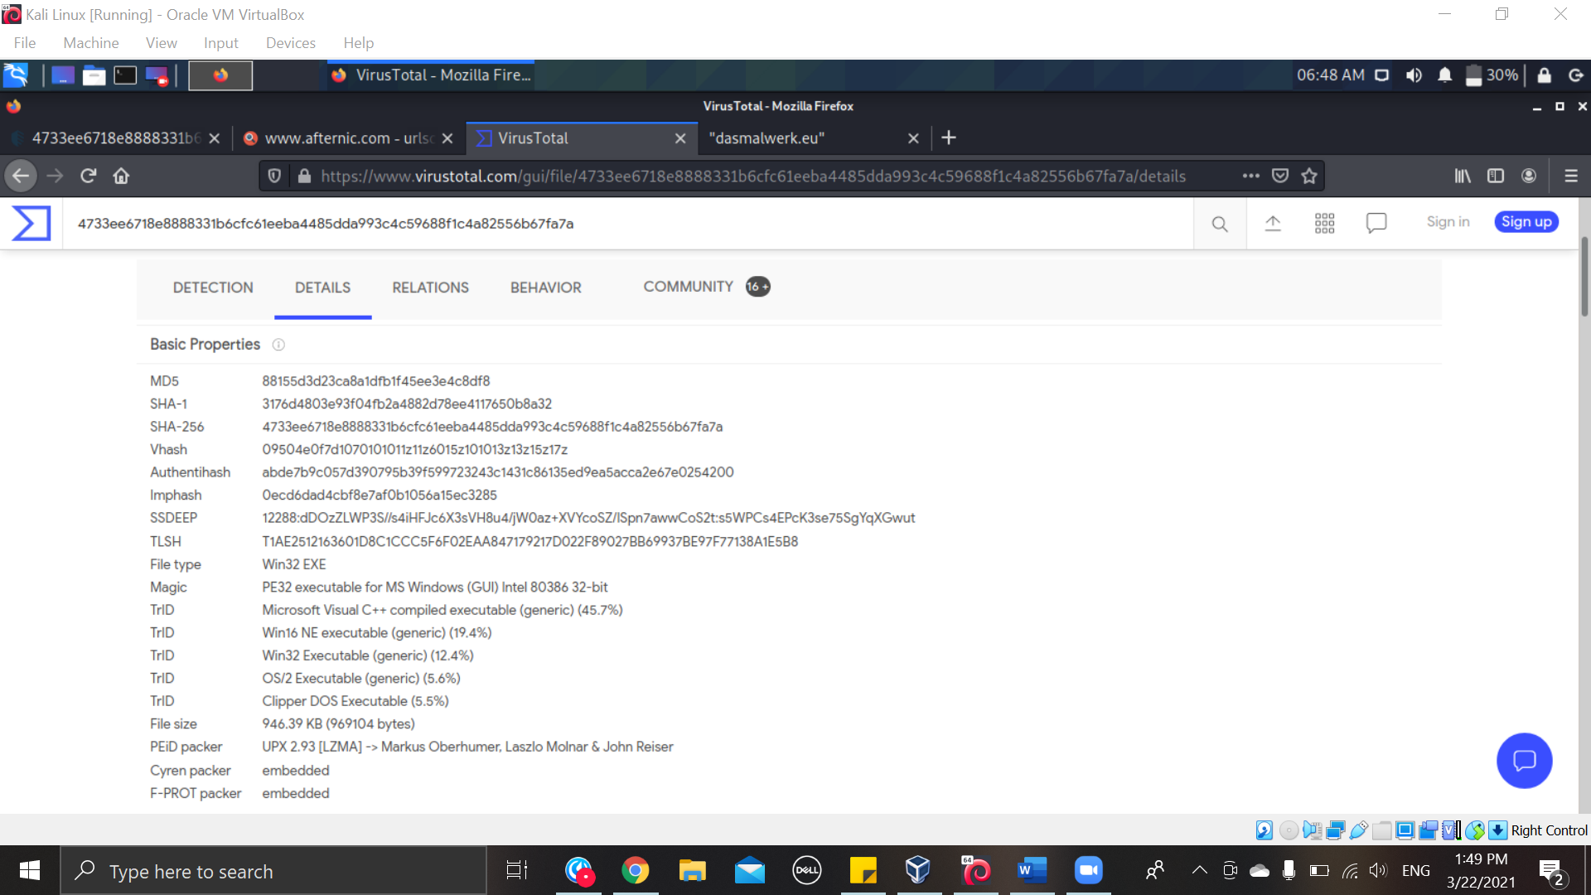

Figure 14

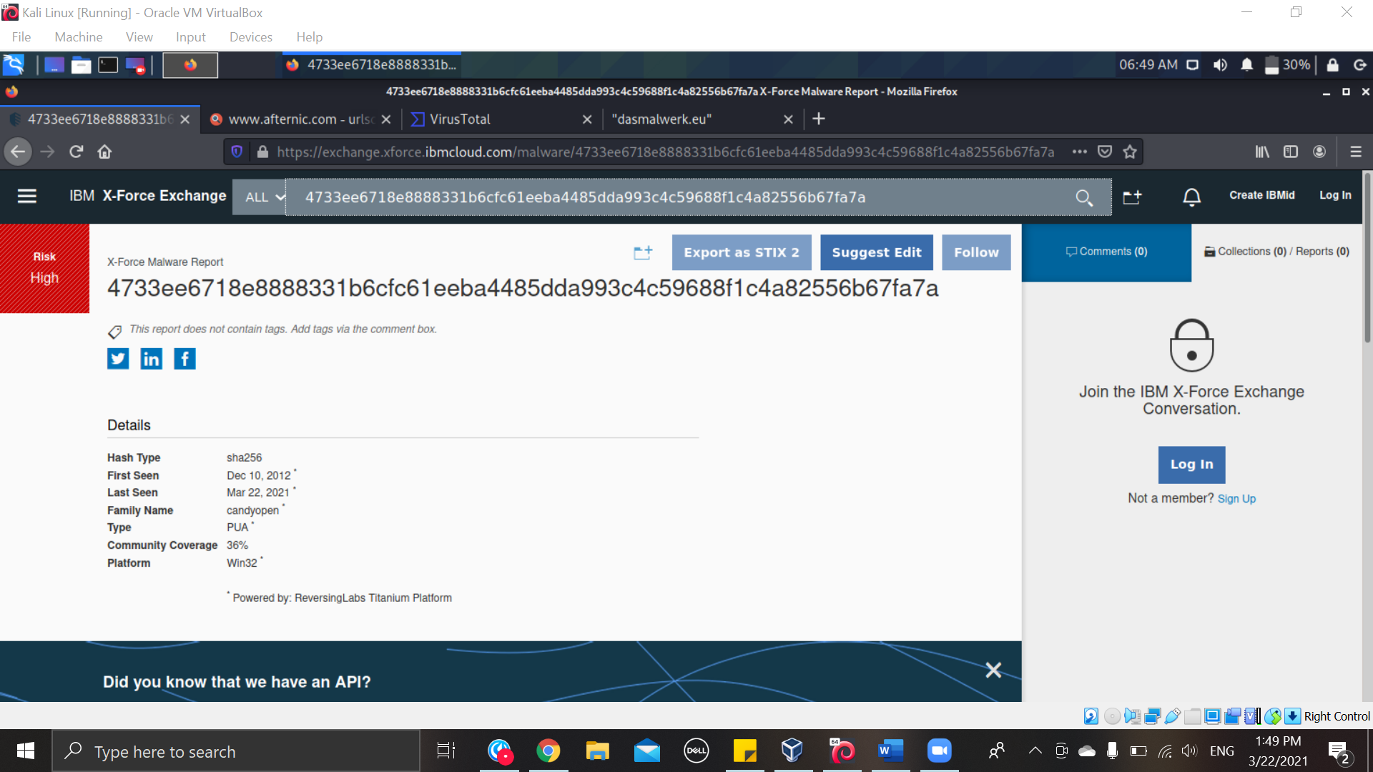

Figure 15

|  |  |  |
| --- | --- | --- |
|  | Malware Name | Hash |
| **6** | eimagePlus | f9e40f57767d7f91167b2c8670184f594ac625ca991a57f5935131c56b66a487 |

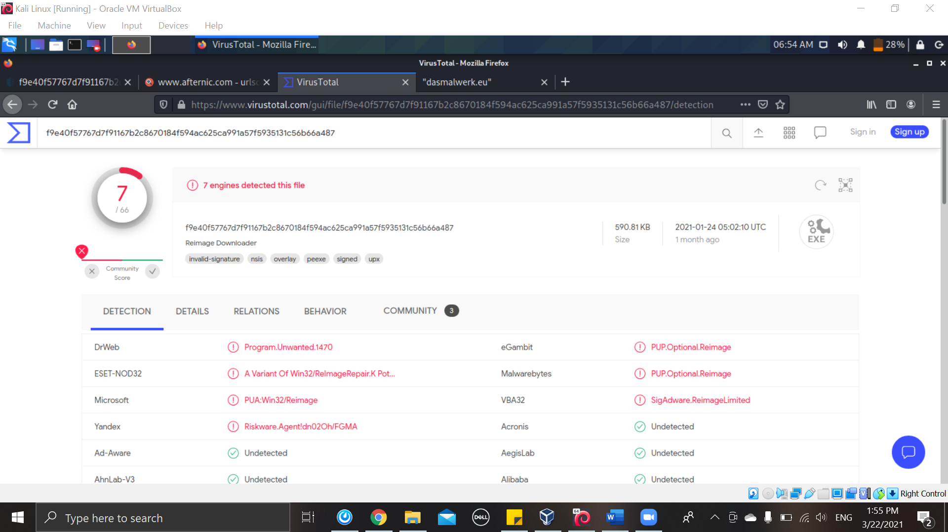

Figure 16

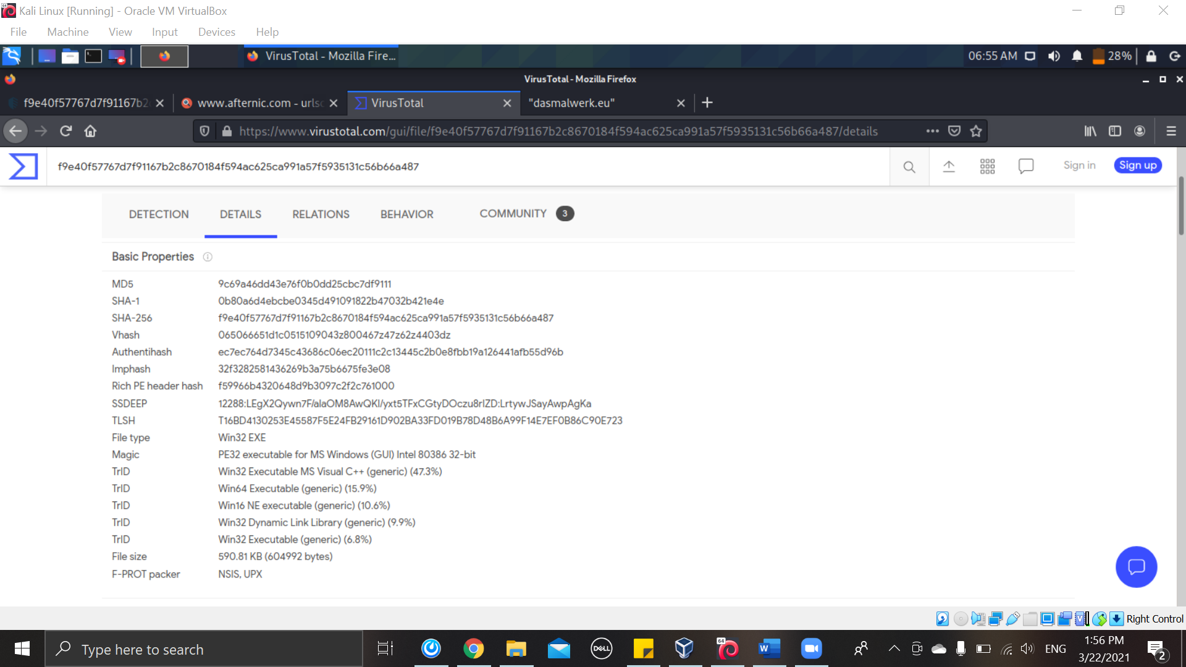

Figure 17

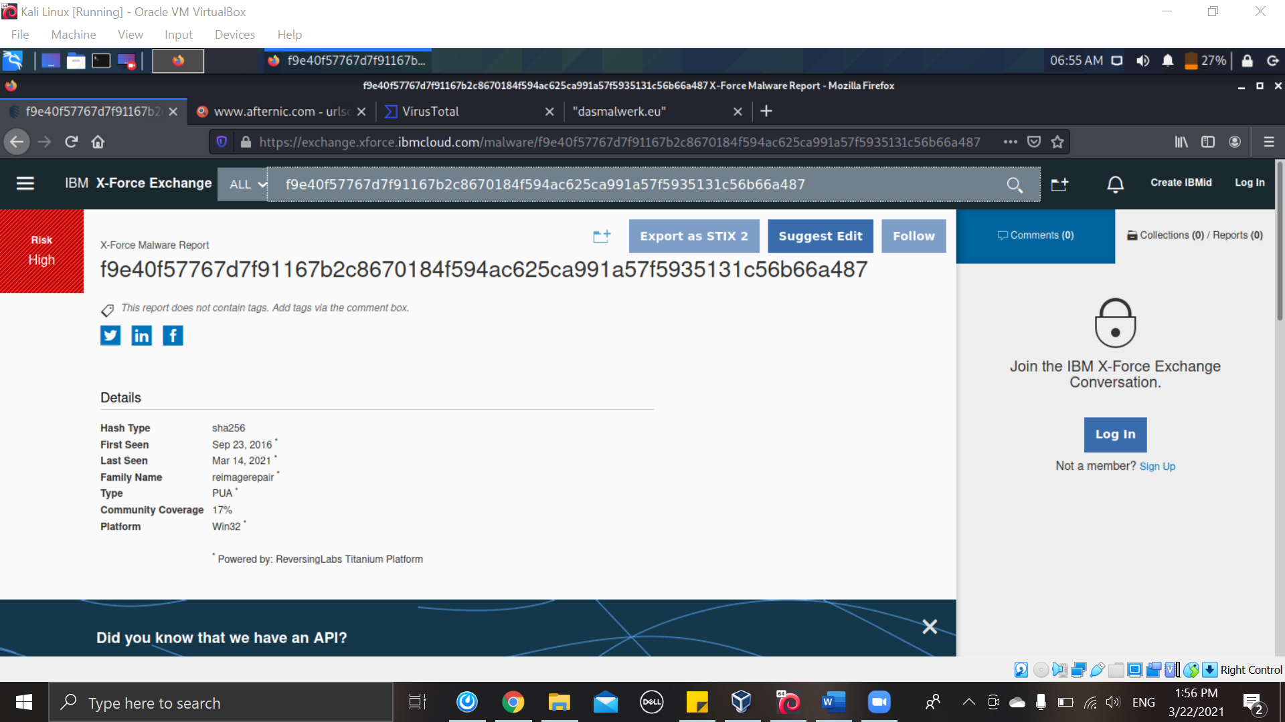

Figure 18

|  |  |  |
| --- | --- | --- |
|  | Malware Name | Hash |
| **7** | Trojan.Agent.CWXQ | 651bebc6a44c008eab324191e8b85e09d5bd26077aa2ea34f6b07eb5d9b75dd5 |

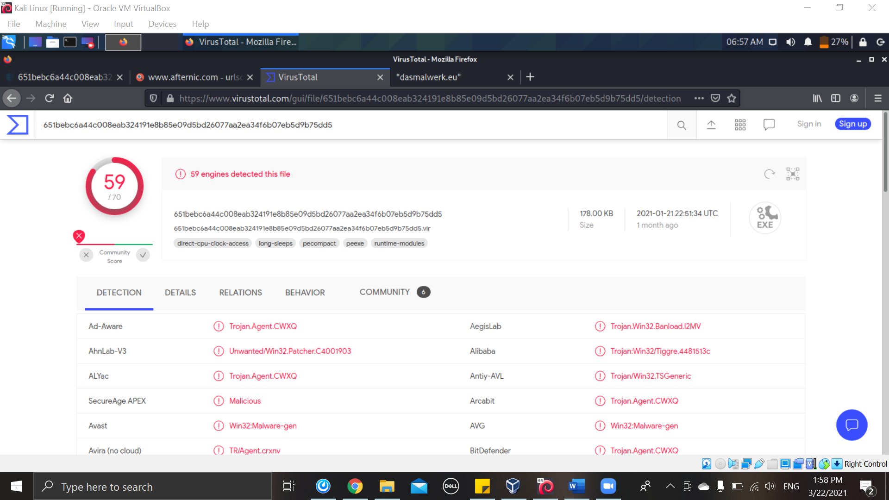

Figure 19

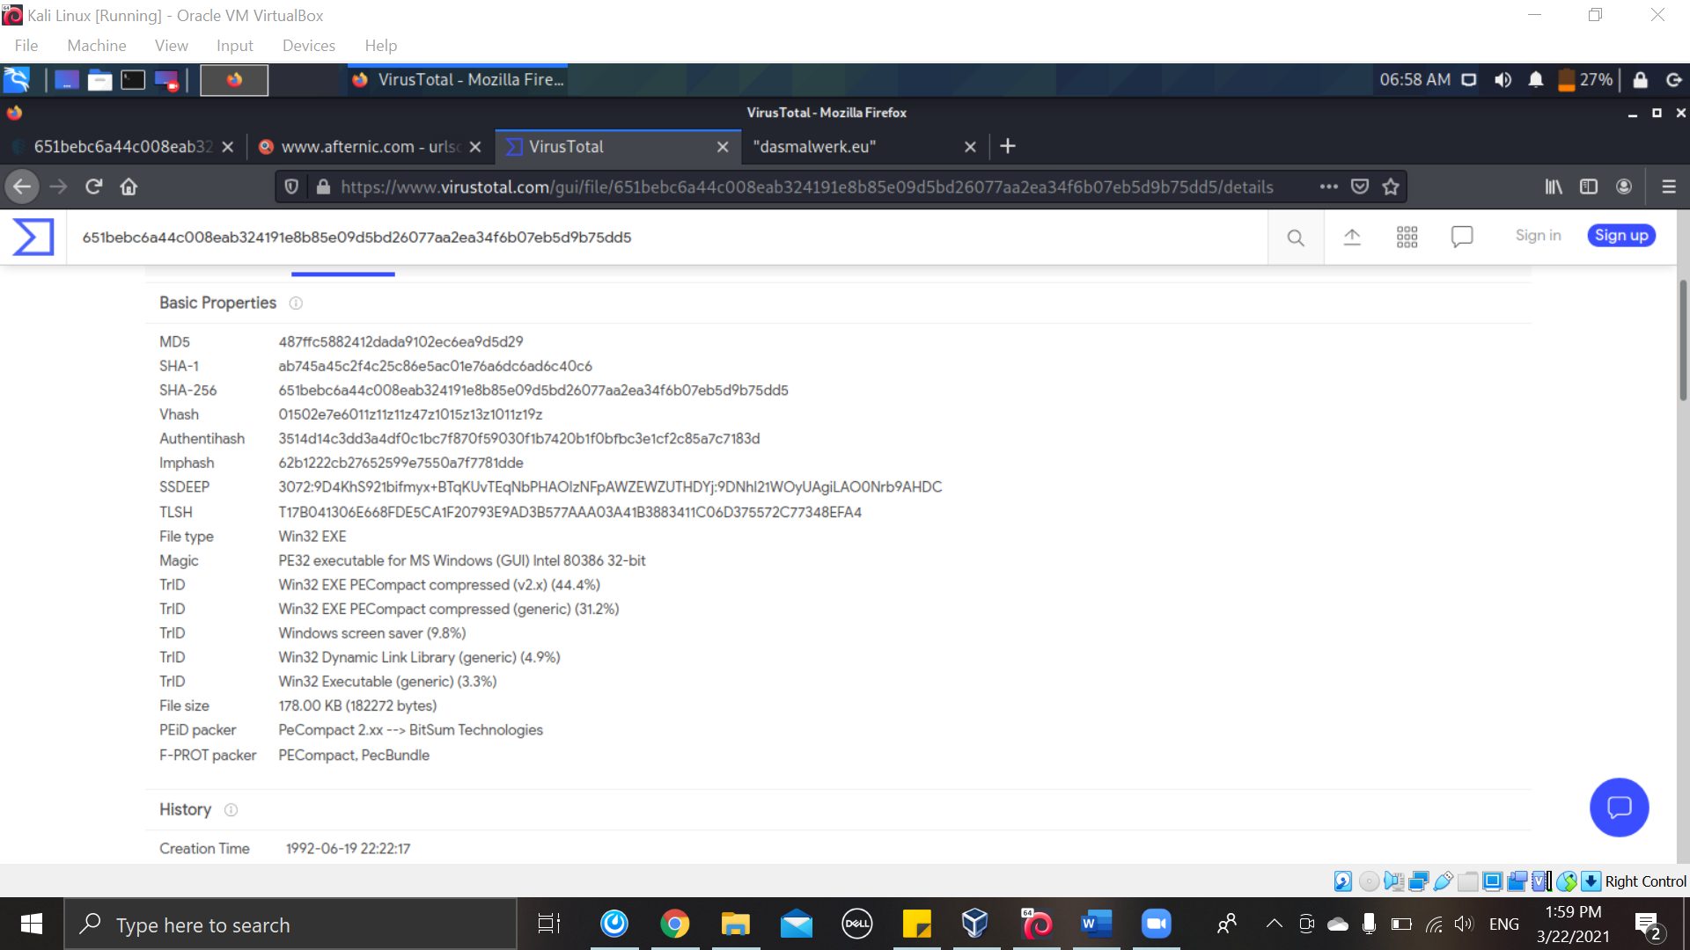

Figure 20

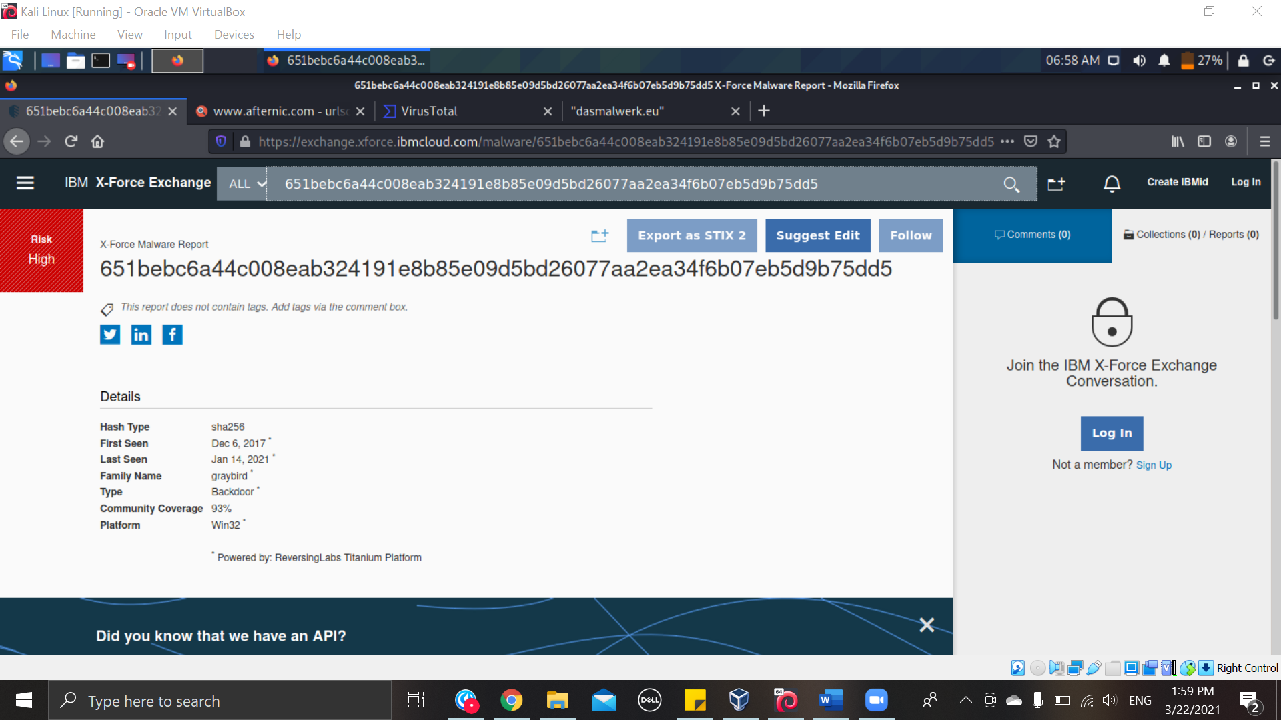

Figure 21

|  |  |  |
| --- | --- | --- |
|  | Malware Name | Hash |
| **8** | Adware.GenericKD.31006658 | c66afad73cc34e9130f070a1834174fe231c55110302ac0104223a3ff0425e2d |

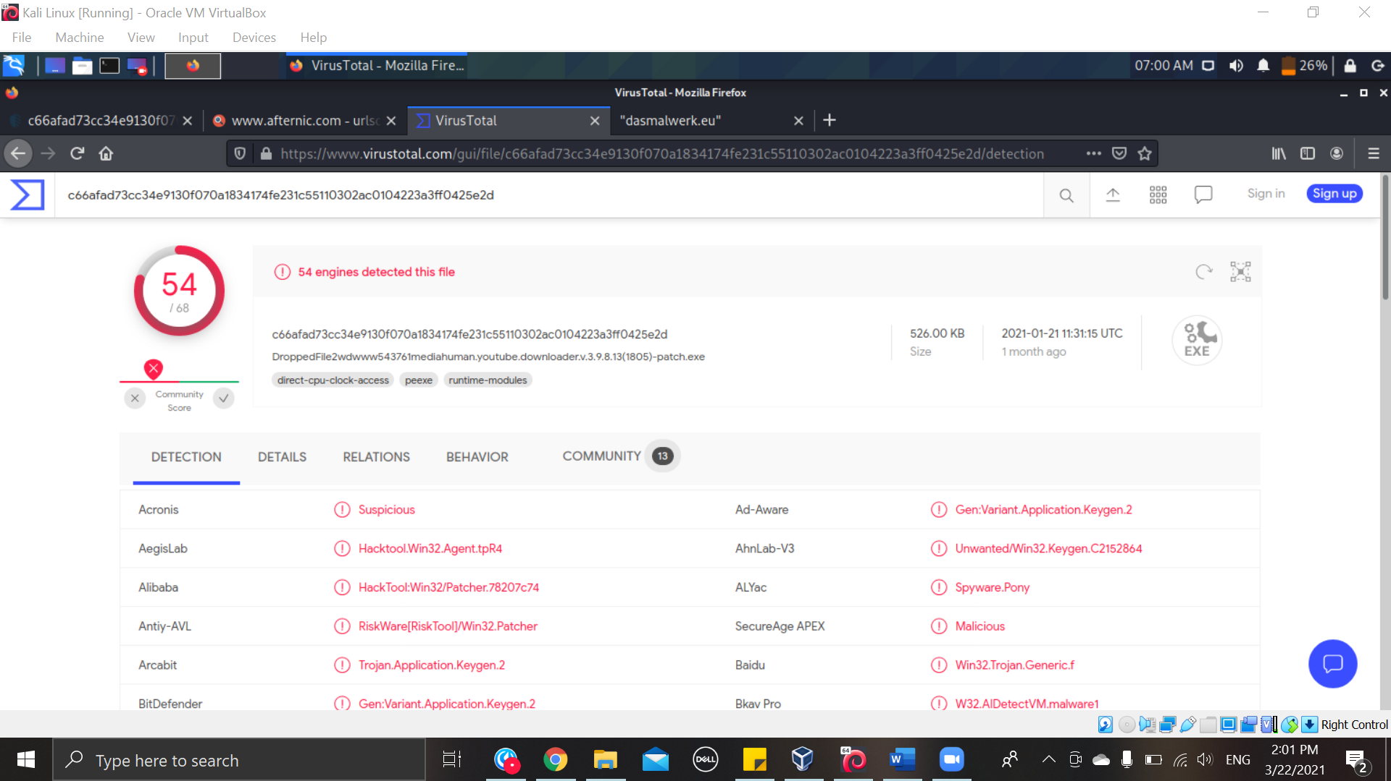

Figure 22

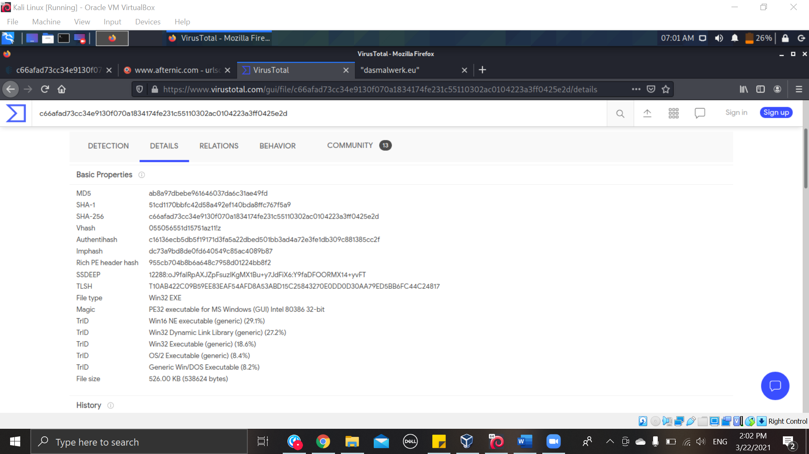

Figure 23

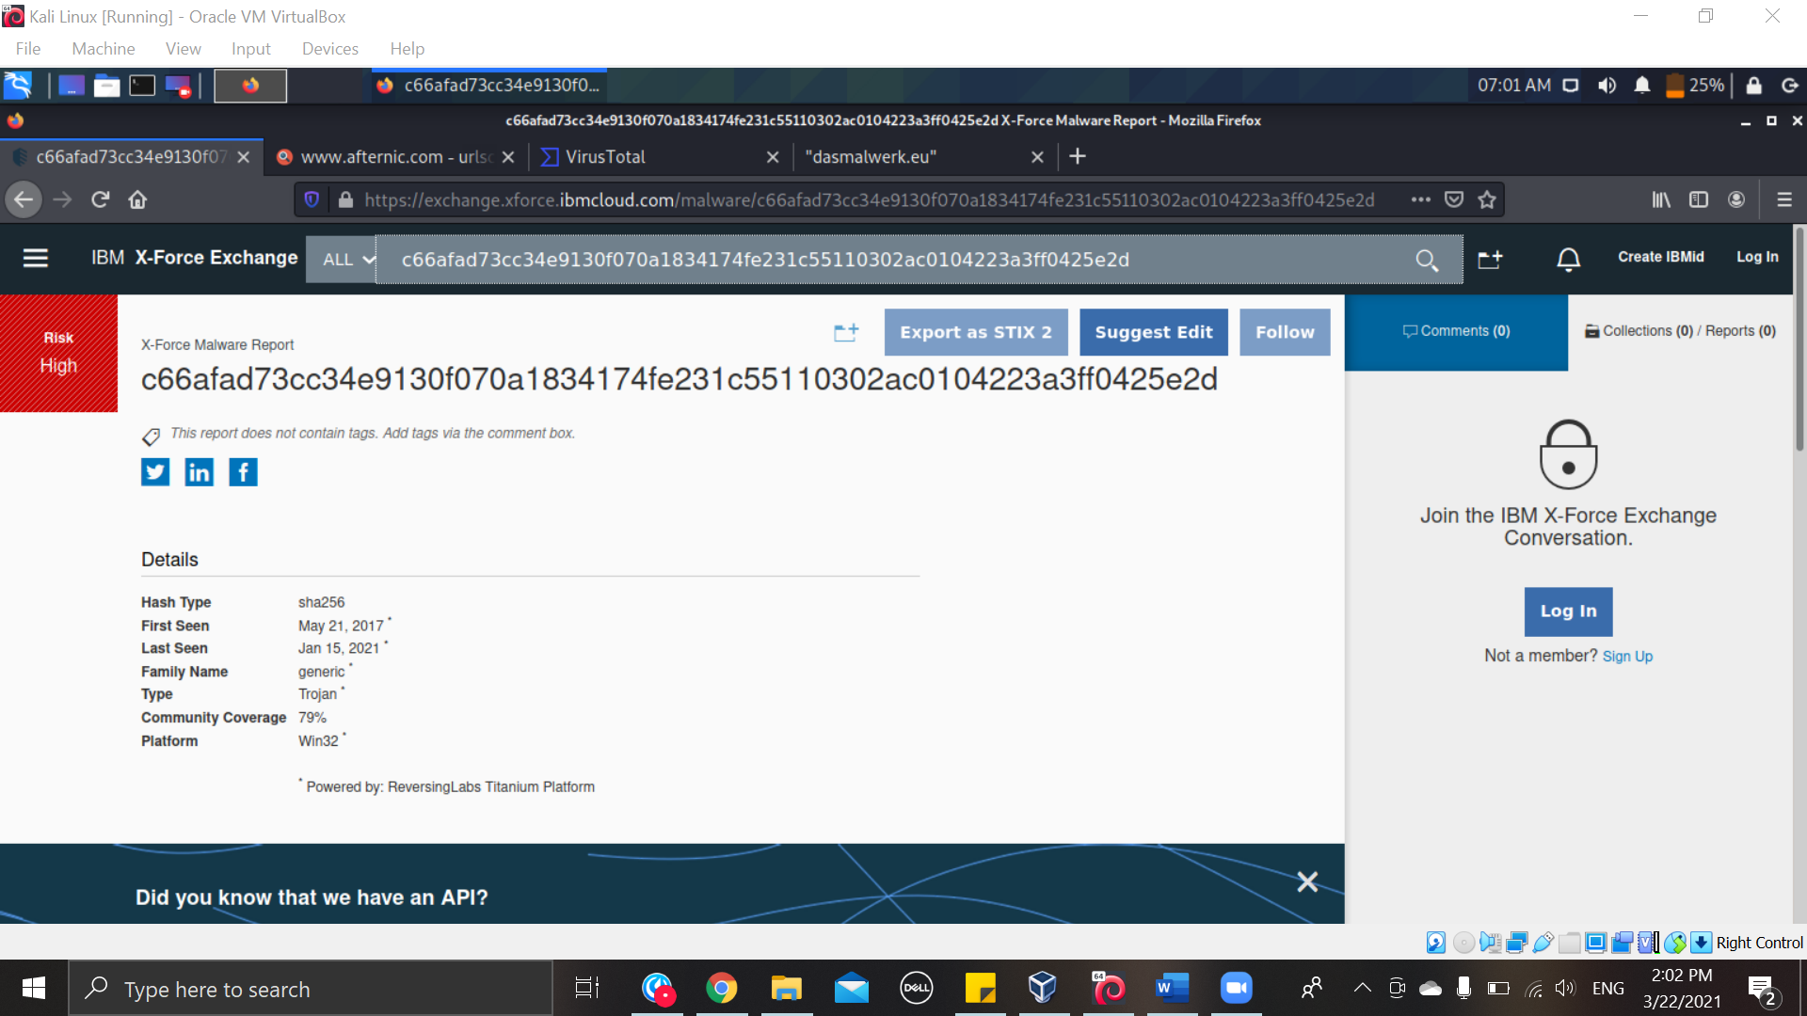

Figure 24

|  |  |  |
| --- | --- | --- |
|  | Malware Name | Hash |
| **9** | Application.Bundler.ADE | d24dd688629ba34c5f6bfd7bb148ac114e164ac6b02ddcab0508770da0880dae |

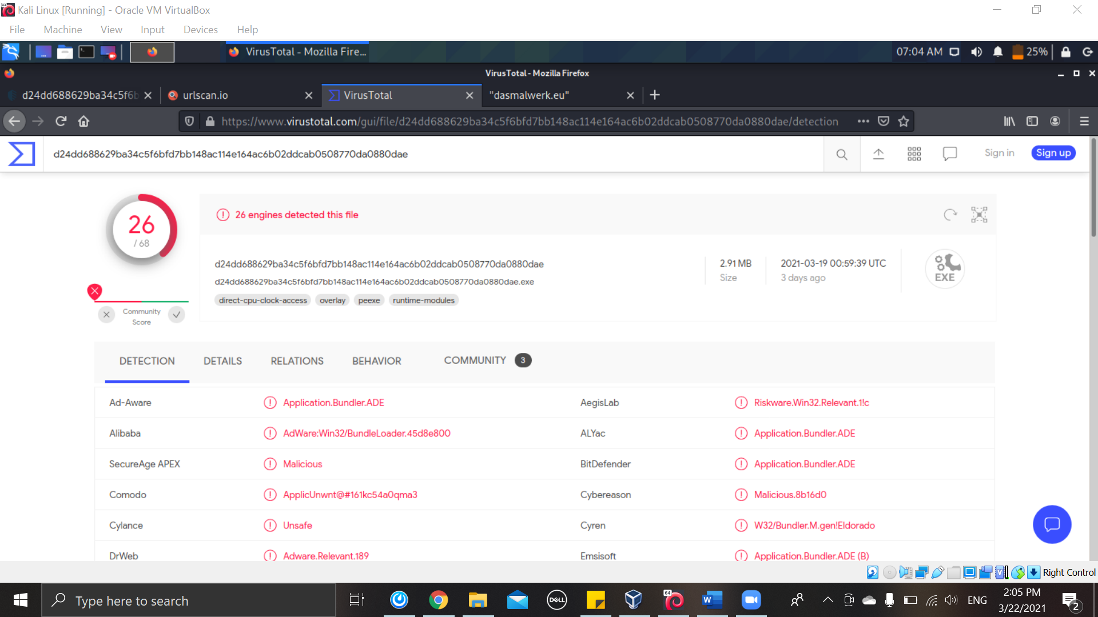

Figure 25

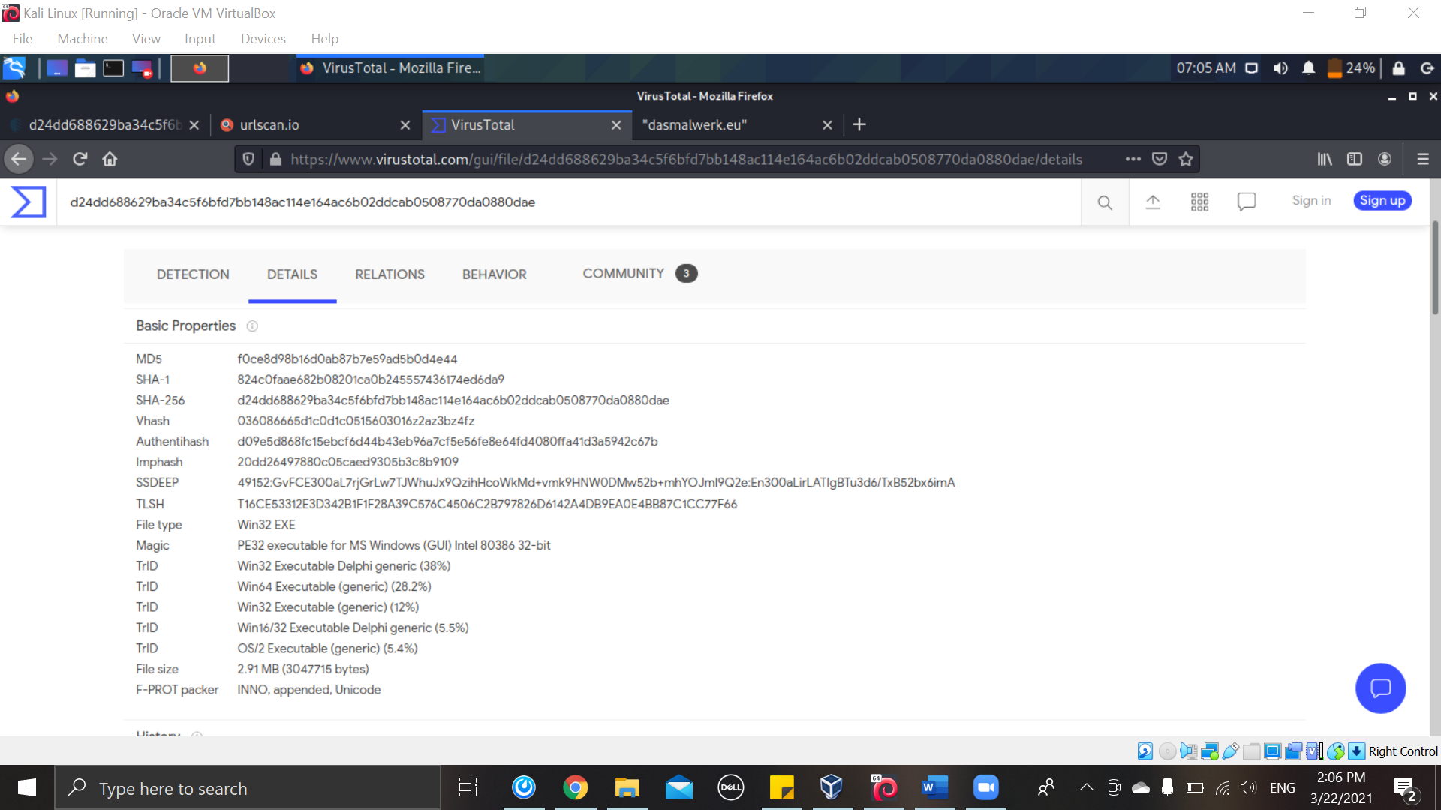

Figure 26

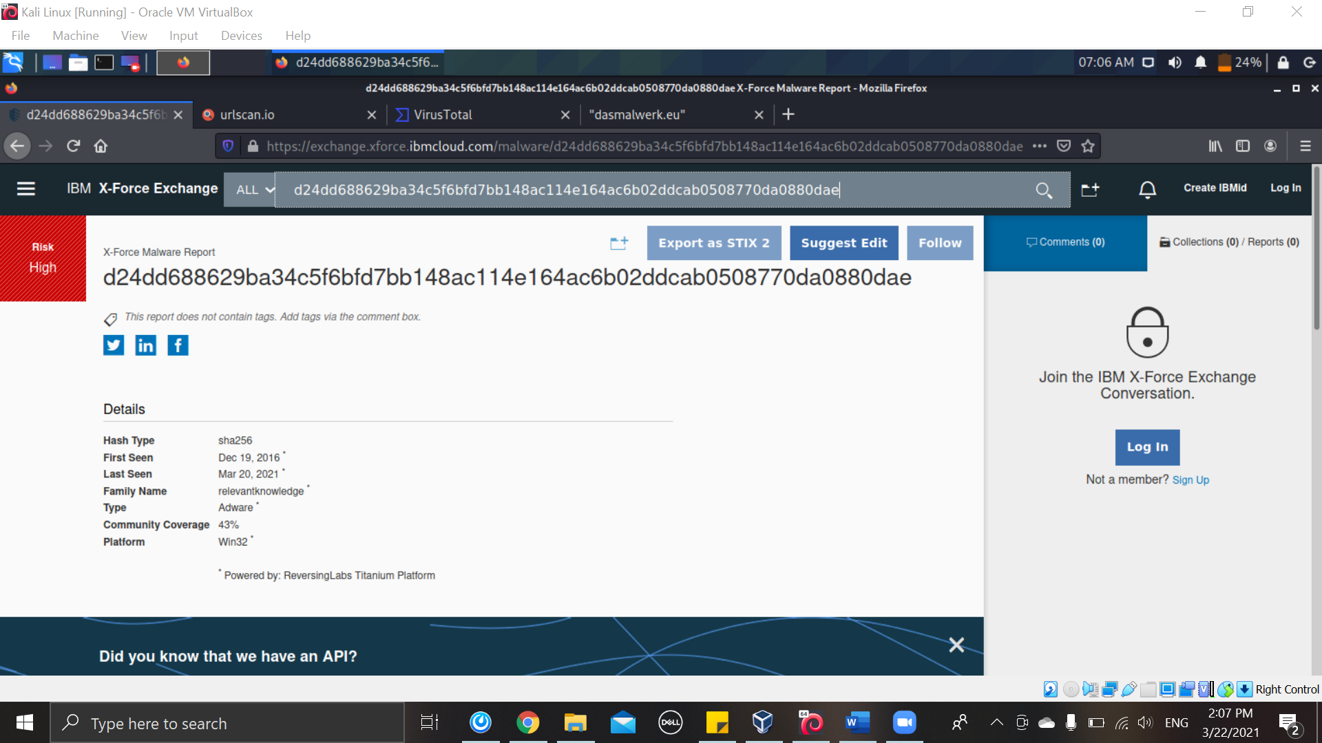

Figure 27

|  |  |  |
| --- | --- | --- |
|  | Malware Name | Hash |
| **10** | Gen:Heur.PonyStealer.2 | 725db081b3ea29cab32c2a6f53a04105c7fb80e3d1b0cede566f15afb68bb4a9 |

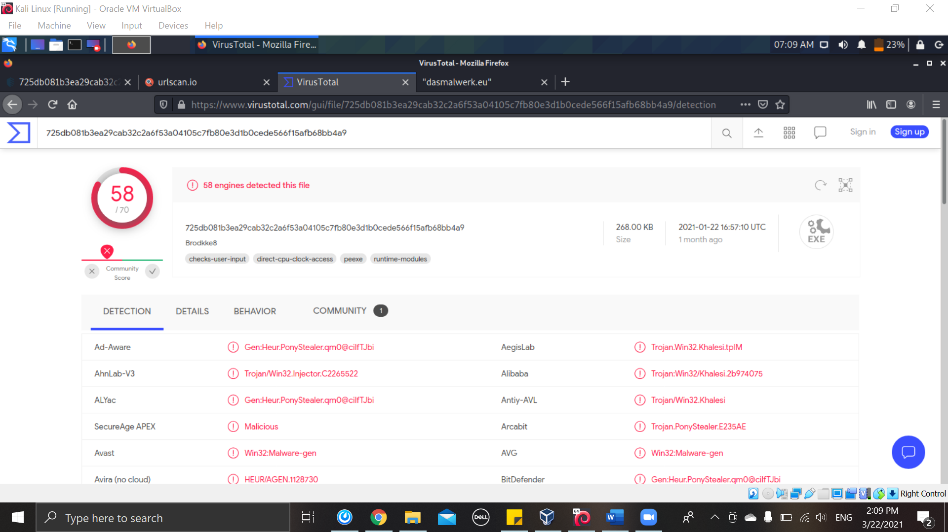

Figure 28

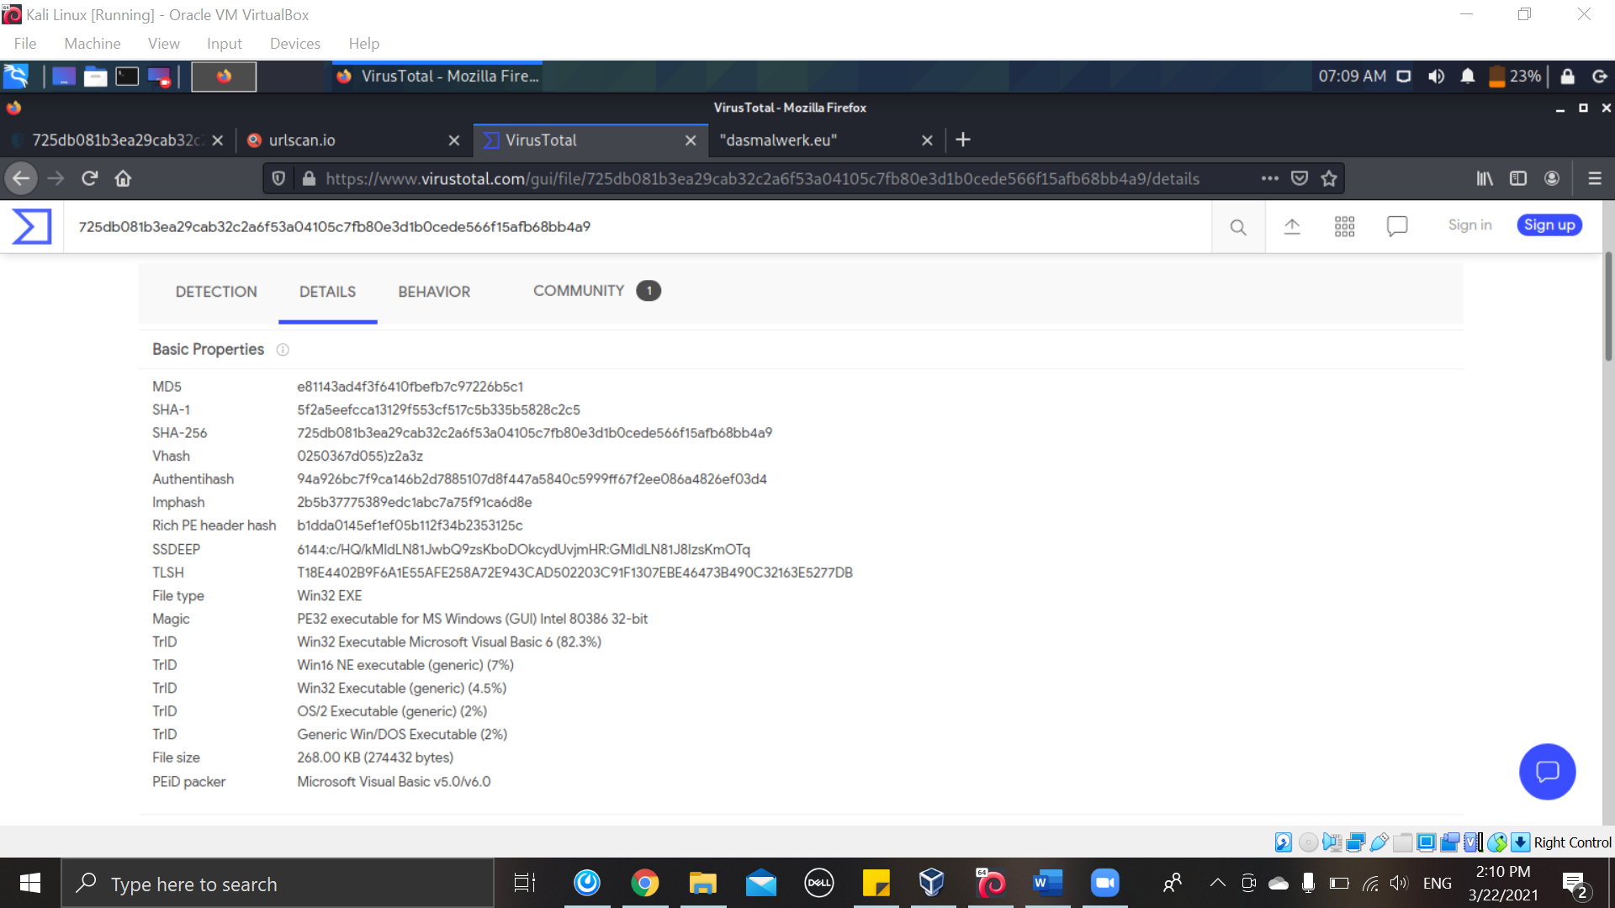

Figure 29

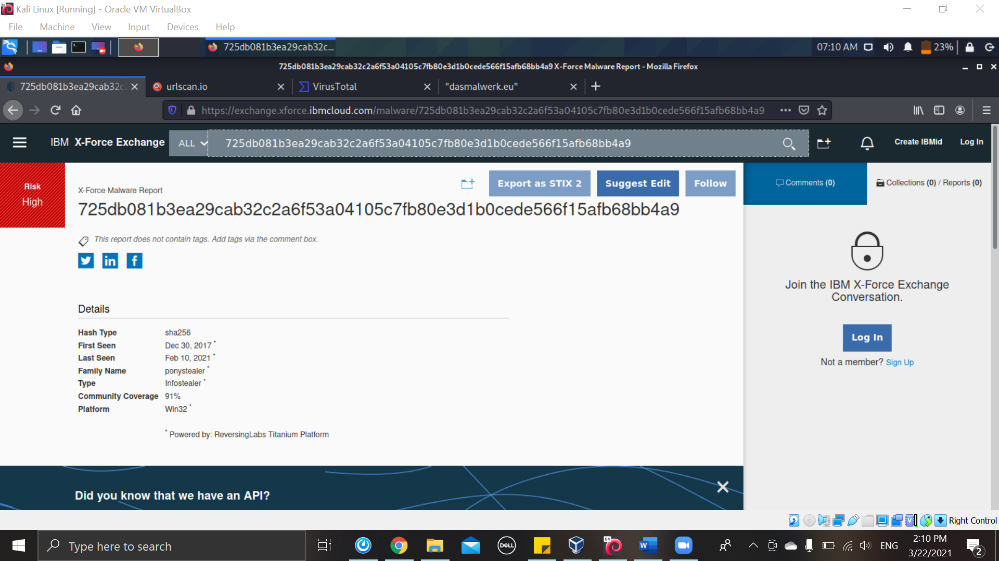

Figure 30

**Reference list**

* “dasmalwerk.eu.” (n.d.). DAS MALWERK // Malware Samples. Retrieved March 22, 2021, from https://dasmalwerk.eu/